H.T No
Regulations:
A20

Sreenidhi Institute of Science and Technology
(An Autonomous Institution)
Code No: 8HC10 Date: 18-Mar-2023 (AN)

B.Tech I-Year I- Semester External Examination, March/April-2023 (Supplementary)
LINEAR ALGEBRA AND CALCULUS (CSE, IT, ECM, CS, AI&ML, DS and IOT)

Time: 3 Hours Max.Marks:70

Note: a) No additional answer sheets will be provided.
b) All sub-parts of a question must be answered at one place only, otherwise it will not be valued.
c) Missing data can be assumed suitably.
Bloom's Cognitive Levels of Learning (BCLL)

Remember | L1 | Apply | L3 | Evaluate | L5
Understand | L2 | Analyze | L4 | Create | L6

Part - A Max.Marks:20

Answer all QUESTIONS.

 |  | BCLL | CO(s) | Marks
1 | Explain consistency of linear system. | L3 | CO1 | [2M]
2 | Define Eigen vector of a matrix. | L2 | CO2 | [2M]
3 | Discuss kernel of a linear map. | L2 | CO3 | [2M]
4 | Give an example of inner product vector space. | L2 | CO4 | [2M]
5 | Analyze geometric interpretation of mean value theorem. | L3 | CO5 | [2M]
6 | Define Beta function. | L1 | CO6 | [2M]
7 | Define Normal form. | L1 | CO | [2M]
8 | Explain linear combination in vector space | L3 | CO | [2M]
9 | Find the Maclaurin series expansion of | L2 | CO | [2M]
10 | Find the Eigen values of 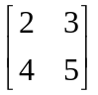 | L2 | CO | [2M]

Part – B Max.Marks:50
ANSWER ANY FIVE QUESTIONS. EACH QUESTION CARRIES 10 MARKS.

 |  |  | BCLL | CO(s) | Marks
11. | a) | Solve by using Gauss elimination method. | L3 | CO1 | [5M]
 | b) | Find the rank of the matrix 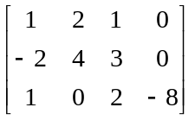 by reducing it to Echelon form. | L2 | CO1 | [5M]
12. | a) | Verify the Cayley-Hamilton theorem for 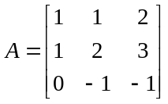 and hence find the inverse. | L3 | CO2 | [5M]
 | b) | Find the Eigen values and Eigen vectors of the matrix 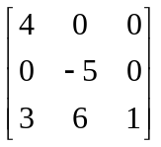 | L2 | CO2 | [5M]
13. | a) | Examine the following set of vectors for linear dependence  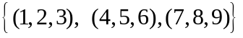 | L3 | CO3 | [5M]
 | b) | Determine whether or not the following vectors form a basis of 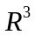 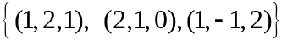 | L4 | CO3 | [5M]
14. | a) | What is the difference between orthogonal and orthonormal vectors | L2 | CO4 | [3M]
 | b) | Apply Gram Schmidt algorithm to orthonormalize the set of vectors 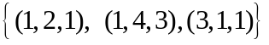 | L3 | CO4 | [7M]
15. | a) | Discuss the applicability of Rolle’s theorem for 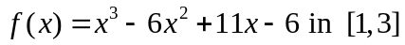 | L2 | CO5 | [5M]
 | b) | Find the value ‘C’ of Cauchy’s Mean value theorem for  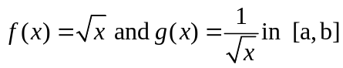 | L3 | CO5 | [5M]
16. | a) | Evaluate 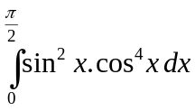, using Beta and Gamma functions. | L5 | CO6 | [5M]
 | b) | Show that 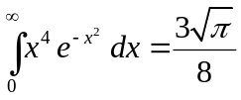 | L3 | CO6 | [5M]
17. | a) | For what values of k the equations have a solution.  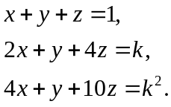 | L3 | CO1 | [5M]
 | b) | Reduce the matrix 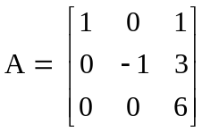to the diagonal form. | L3 | CO2 | [5M]
18. | a) | Let S= {v₁, v₂, …….v_{n}} be an orthogonal set of non-zero vectors in an inner product space Then prove that S is linearly independent. | L3 | CO4 | [4M]
 | b) | Verify Lagrange’s Mean value theorem for  for all 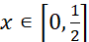 | L4 | CO5 | [3M]
 | c) | Prove that 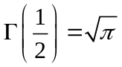 | L2 | CO6 | [3M]

-- 00 -- 00 –

